**Milstone-04**

**Final Project – Milestone 4**

**Fall 2019 User Experience Design-Section 05 12/06/2019**

**Project Title:** Online Examination

**Team Name:** Ignite

**Team Members:**

1. Sai Varun Reddy Anugu
2. Sai Samrat Adloor
3. Sravya Katpally
4. Millindar Reddy Maligireddy
5. Sai Nikhil Pippara

**Team Logo:**



**Group Members Photo**

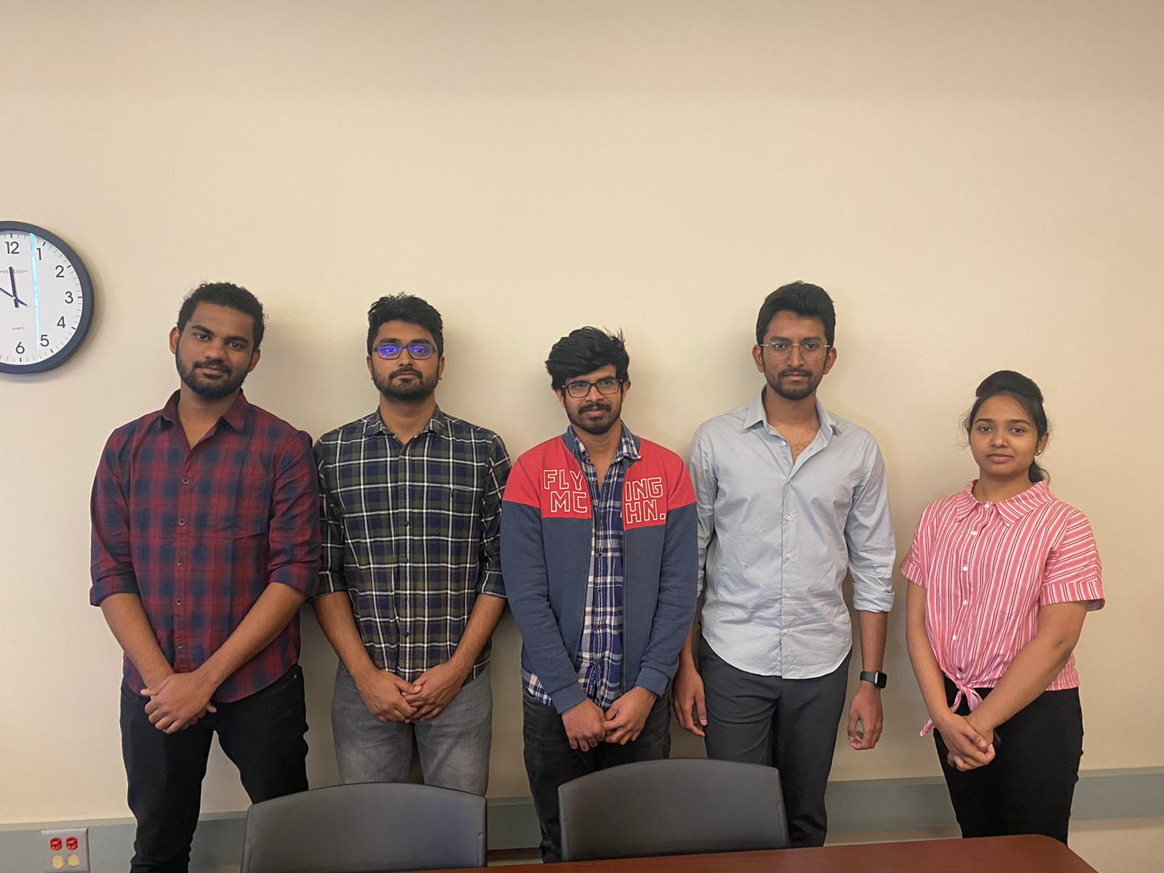

|  |  |  |
| --- | --- | --- |
| **S. No** | **Table of Contents** | **Page No** |
| **I** | **Introduction** | 03 |
| **II** | **Requirement Analysis** | 04 |
| 1. | Ascertain user needs: | 04 |
| 2. | Reliability | 04 |
| 3. | Ensure Standardization, Integrity, Portability, and Consistency | 04 |
| 4. | Budget and Time | 04 |
| **III** | **Functional Requirements** | 04 |
| **IV** | **E/R diagram/Data Model** | 05 |
| **V** | **Task List** | 05 |
| **VI** | **Informed Consent Document** | 06 |
| **VII** | **Usability Metrics** | 08 |
| 1. | Usability Test Plan | 08 |
| 2. | Usability Measures | 09 |
| 3. | Usability Logs | 10 |
| 4. | Defect List | 12 |
| 5. | Usability Testing Video Link | 15 |
| **VIII** | **Website Screenshots** | 16 |
| **IX** | **Heuristic Evaluation of Interface Based on Eight Golden Rules of Interface Design** | 38 |

**Introduction**

* This project aims to develop a website which allows users to take an exam on the registered course.
* The user can also register for a course through online and take the exam on the particular course.
* User can see the score once user submitted the exam.
* The admin is allowed to schedule the exam and can also approve or reject the user request.

**User:**

* Users must be able to register and sign up to take the exam.
* User must be able to view the question paper online and choose the answers.
* Exam score should appear as soon as the user takes the exam.
* User can view and edit his profile.
* User can see all the exams he has enrolled to.

**Admin:**

* Admin must be able to login to the website.
* Admin must be able to schedule examinations,
* Admin should be able to manage user registration.
* Admin can post questions for the examination.

**Requirements Analysis:**

**Ascertain user needs**

* In this website, the user must be able to find the list of examinations and must be able to attempt the examination.
* User must be able to view question paper online and choose the answers.
* The user should be able to see the score as soon as the user completes the exam.
* User should be able to see all the exams he registered to.

**Ensure Reliability**

* To ensure the reliability, the user can take the exam only if the user is able to login.
* Navigating from one page to other should be easy, when the user see the website for the first time.
* Database for the examination site should be stored in app data using the data replication techniques.
* Only the admin has access to add or remove subject or change any questions in particular subject.

**Promote Standardization, Integrity, Portability and Consistency**

* Navigation of the pages should be consistent along with the font size, colors and style to make the user comfortable while taking the examination.
* The website should be responsive so that user can register from any device.
* If needed we can also provide the meaningful signifiers.

**Within the given Budget and Time**

* The final date for the project completion is Dec 06, 2019.
* Cost of the project is approximately 1100 USD.

**Functional Requirements:**

FR1: The website must allow new users to signup/register without any difficulty.

FR2: The portal must ensure the people registered already are entering the correct username and password. The system must provide appropriate feedback, warning or error, confirmation messages.

FR3: The system should allow users to edit or view profile whenever they needed.

FR4: The user must be able to search for any exam they wish to take by clicking on exams tab where they can find the links to the appropriate exam.

FR5: The user must be able to view the question paper online and choose the answers.

FR6: The user can see all the exams they have enrolled to.

FR7: The exam score should appear as soon as the user completes the exam.

FR8: The admin must be able to schedule examinations and also can post questions for the examination.

**ER diagram:**

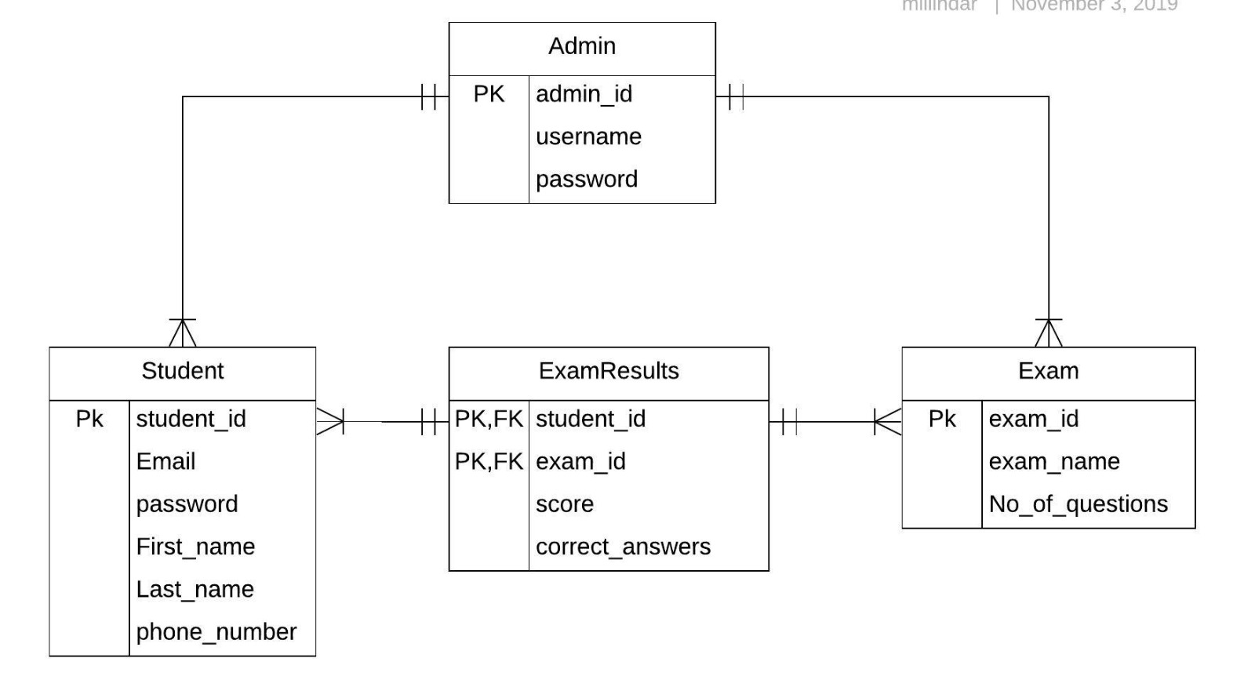

**Tasks plan for performing usability testing:**

**Task 1: To Register as a User**

**Description:**  On opening the website, there is a Login and Signup page for the user at Right Top Corner.

**Task 2: Login/Registration**

**Description:** As soon as the user registers they are directed to Login Page.

**Task 3: To take an exam**

**Description:** As soon as the user logged in there are available exams. Once the exam is selected the user should be able to see the Questions.

**Task 4: Questions in the exam**

**Description:** Once the user see the exam the user should be able to select the answer/answers or type the answer in the text box provided.

**Task 5: Answering the questions:**

**Description:** Once the user selects the answer he should be able to go to the next question by clicking 🡪 button.

**Task 6: Next Question:**

**Description:** User should be able to go to the next question without even answering the before question, but before submitting he should answer all the question.

**Task 7: Admin**

**Description:** Admin can be able to add/remove the subjects, or remove/add the questions of particular subject.

**Task 9: Upcoming Events**

**Description:** Faculty can post upcoming events provided at the right side of the faculty page.

**Task 10: Previous/Next Questions**

**Description:** While taking an exam the user should be able to navigate to previous or next question.

**Task 11: Edit Profile**

**Description**: The user should be able to edit the profile by changing the name or the exams enrolled.

**Task 12: Logout**

**Description**: User should be able to logout as soon as he completes the examination.

**Informed Consent: (Scanned Copies)**





**Usability Test Plan:**

**Team roles and users**

|  |  |
| --- | --- |
| **Testing Place** | B.D Owens Library |
| **Testing Time** | 4:00 PM – 4:40 PM(Monday) - User 1  4:40 PM – 5:05 PM(Monday) – User 2 |
| **Finding Test Users:** | University Campus |
| **Test Users** | Gireesh Koneni, Haritha Atmakuri |
| **Log Taker** | Millindar Reddy Maligireddy |
| **Human Computer** | Sai Varun Reddy Anugu |
| **Video Recorder** | Sai Samrat Adloor |
| **Observer** | Sai Nikhil Pippara |
| **Note Taker** | Sravya Katpally |

**Test Methodologies and Planning**

|  |  |
| --- | --- |
| Test Method | The user should be able to perform actions for required tasks. |
| Basic Knowledge | As a basic knowledge, user should first register and login to the website and then perform actions like |
| Data Collection | Data is collected from user actions and video was recorded. |
| Questionnaire | Study conducted about the design of the website with novice and expert users. |

**Usability logs:**

**User#1:**

|  |  |  |  |  |  |  |
| --- | --- | --- | --- | --- | --- | --- |
| **Task** | **Start time**  **(HH:MM:SS)** | **End time**  **(HH:MM:SS)** | **No of mouse clicks** | **No of key strokes** | **No of errors** | **Defects/comments** |
| **T1** | **4:03:00** | **4:06:00** | **2** | **10** | **0** | **---** |
| **T2** | **4:06:00** | **4:08:00** | **2** | **5** | **0** | **---** |
| **T3** | **4:08:00** | **4:09:00** | **1** | **0** | **0** | ---- |
| **T4** | **4:09:00** | **4:11:00** | **1** | **0** | **1** | **Hard to read the questions with the color** |
| **T5** | **4:11:00** | **4:12:00** | **1** | **0** | **0** | **---** |
| **T6** | **4:12:00** | **4:17:00** | **1** | **1** | **0** | **---** |
| **T7** | **4:17:00** | **4:19:00** | **1** | **0** | **1** | **Faced problems with the font size** |
| **T8** | **4:19:00** | **4:21:00** | **1** | **1** | **0** | **---** |
| **T9** | **4:21:00** | **4:24:00** | **1** | **6** | **0** | ---- |
| **T10** | **4:24:00** | **4:24:40** | **1** | **4** | **0** | **---** |
| **T11** | **4:24:40** | **4:29:40** | **1** | **10** | **1** | **Hard to find admin login** |
| **T12** | **4:29:40** | **4:31:20** | **1** | **6** | **0** | **---** |
| **T13** | **4:31:20** | **4:32:00** | **1** | **0** | **0** | **---** |
| **T14** | **4:32:00** | **4:36:00** | **1** | **4** | **0** | **---** |
| **T15** | **4:36:00** | **4:38:40** | **1** | **4** | **0** | **---** |
| **T16** | **4:38:40** | **4:39:20** | **1** | **0** | **0** | **---** |
| **T17** | **4:39:20** | **4:40:00** | **1** | **0** | **0** | **---** |

**User#2:**

|  |  |  |  |  |  |  |
| --- | --- | --- | --- | --- | --- | --- |
| **Task** | **Start time**  **(HH:MM:SS)** | **End time**  **(HH:MM:SS)** | **No of mouse clicks** | **No of key strokes** | **No of errors** | **Defects/comments** |
| **T1** | **4:40:00** | **4:42:40** | **2** | **10** | **0** | **---** |
| **T2** | **4:42:40** | **4:44:00** | **2** | **5** | **0** | **---** |
| **T3** | **4:44:00** | **4:44:50** | **1** | **0** | **0** | ---- |
| **T4** | **4:44:50** | **4:46:30** | **1** | **0** | **0** | **---** |
| **T5** | **4:46:30** | **4:47:10** | **1** | **0** | **0** | **---** |
| **T6** | **4:47:10** | **4:49:50** | **1** | **1** | **0** | **---** |
| **T7** | **4:49:50** | **4:51:50** | **1** | **0** | **0** | **---** |
| **T8** | **4:51:50** | **4:53:10** | **1** | **1** | **0** | **---** |
| **T9** | **4:53:10** | **4:55:10** | **1** | **6** | **0** | ---- |
| **T10** | **4:55:10** | **4:55:30** | **1** | **4** | **0** | **---** |
| **T11** | **4:55:30** | **4:58:30** | **1** | **10** | **1** | **Hard to find admin login** |
| **T12** | **4:58:30** | **4:59:30** | **1** | **6** | **0** | **---** |
| **T13** | **4:59:30** | **5:00:00** | **1** | **0** | **0** | **---** |
| **T14** | **5:00:00** | **5:02:00** | **1** | **4** | **0** | **---** |
| **T15** | **5:02:00** | **5:03:20** | **1** | **4** | **0** | **---** |
| **T16** | **5:03:20** | **5:04:20** | **1** | **0** | **0** | **---** |
| **T17** | **5:04:20** | **5:05:00** | **1** | **0** | **0** | **---** |

**Usability Measures:**

**User#1:**

|  |  |  |  |  |  |  |  |  |  |  |  |  |  |  |  |  |  |
| --- | --- | --- | --- | --- | --- | --- | --- | --- | --- | --- | --- | --- | --- | --- | --- | --- | --- |
| **Usability measures** | **T1** | **T2** | **T3** | **T4** | **T5** | **T6** | **T7** | **T8** | **T9** | **T10** | **T11** | **T12** | **T13** | **T14** | **T15** | **T16** | **T17** |
| **Speed of performance**  **(HH:MM:SS)** | **0:3:00** | **0:2:00** | **0:1:00** | **0:2:00** | **0:1:00** | **0:5:00** | **0:2:00** | **0:2:00** | **0:3:00** | **0:0:40** | **0:5:00** | **0:2:20** | **0:1:10** | **0:4:10** | **0:2:20** | **0:1:20** | **0:00:35** |
| **Rate of errors**  **(SEC)** | **0** | **0** | **0** | **0.02.00** | **0** | **0** | **0.03.00** | **0** | **0** | **0** | **0.04.10** | **0** | **0** | **0** | **0** | **0** | **0** |

**User#2:**

|  |  |  |  |  |  |  |  |  |  |  |  |  |  |  |  |  |  |
| --- | --- | --- | --- | --- | --- | --- | --- | --- | --- | --- | --- | --- | --- | --- | --- | --- | --- |
| **Usability measures** | **T1** | **T2** | **T3** | **T4** | **T5** | **T6** | **T7** | **T8** | **T9** | **T10** | **T11** | **T12** | **T13** | **T14** | **T15** | **T16** | **T17** |
| **Speed of performance**  **(HH:MM:SS)** | **0:2:00** | **0:1:00** | **0:0:40** | **0:1:20** | **0:00:40** | **0:3:10** | **0:1:20** | **0:1:10** | **0:2:00** | **0:0:20** | **0:3:00** | **0:1:20** | **0:00:40** | **0:3:10** | **0:1:20** | **0:1:00** | **0:00:25** |
| **Rate of errors**  **(SEC)** | **0** | **0** | **0** | **0** | **0** | **0** | **0** | **0** | **0** | **0** | **0.03.10** | **0** | **0** | **0** | **0** | **0** | **0** |

**Defect List:**

|  |  |  |  |
| --- | --- | --- | --- |
| **S.no** | **Defects** | **User1** | **User2** |
| **1** | **User faced problem in finding login button for Admin** | **Yes** | **Yes** |
| **2** | **User hard to read the questions with the color** | **Yes** | **No** |
| **3** | **User faced issue with the font size** | **Yes** | **No** |

**Subjective satisfaction:**

**1-Not satisfied             2-Poor 3- average          4-Good        5-Excellent**

|  |  |  |
| --- | --- | --- |
| **Subjective satisfaction Question** | **User 1** | **User 2** |
| **Overall, I am satisfied with how easy it is to use this system** | **5** | **5** |
| **I can effectively complete this work while using this system** | **4** | **4** |
| **Whenever I make a mistake using the system. I recover easily and quickly** | **4** | **5** |
| **The interface of this system is pleasant** | **5** | **5** |
| **It is easy to find the information I needed** | **5** | **5** |

**Feedback Forms: (Scanned Copies)**





**Video for the Usability test:**

**Link:** <https://drive.google.com/file/d/1Bnf-RXVSxrJZ5G7vcDzGMnEXMUhMve9k/view>

**Screenshot of interface:**

**Home page:**

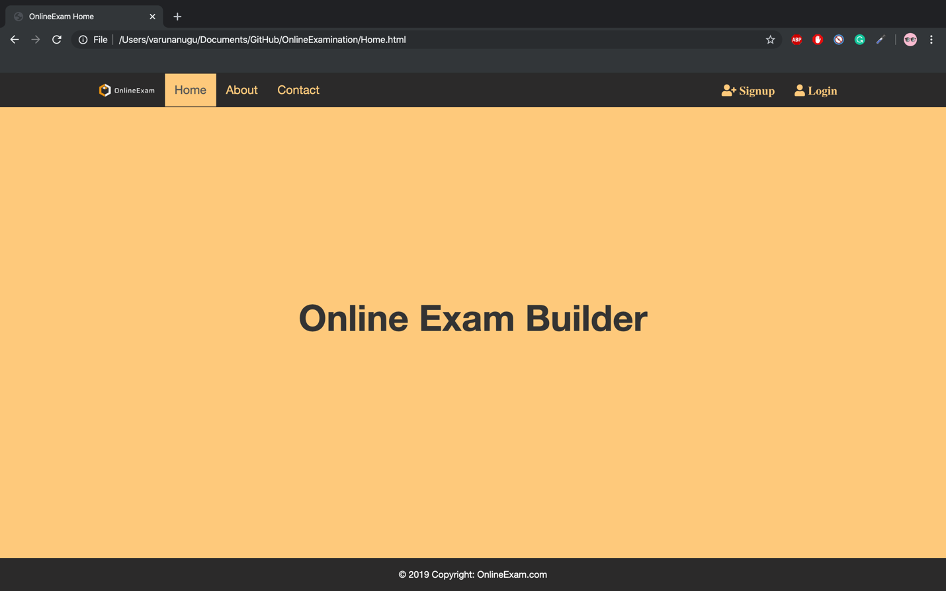

**About us page:**

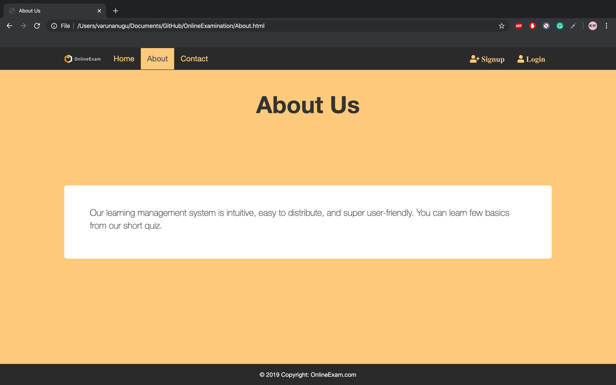

**Contact Page:**

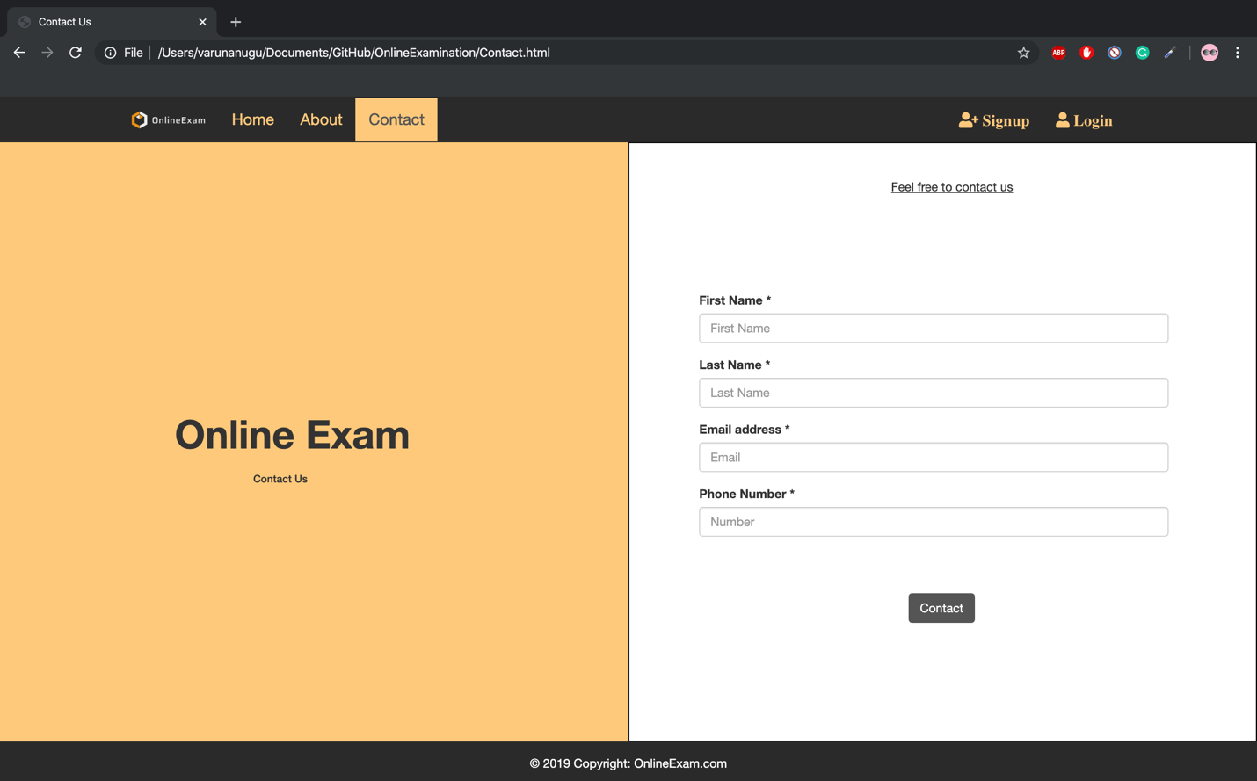

**Contact submission page:**

When we press contact button After filling all the required fields it will navigate to this page.

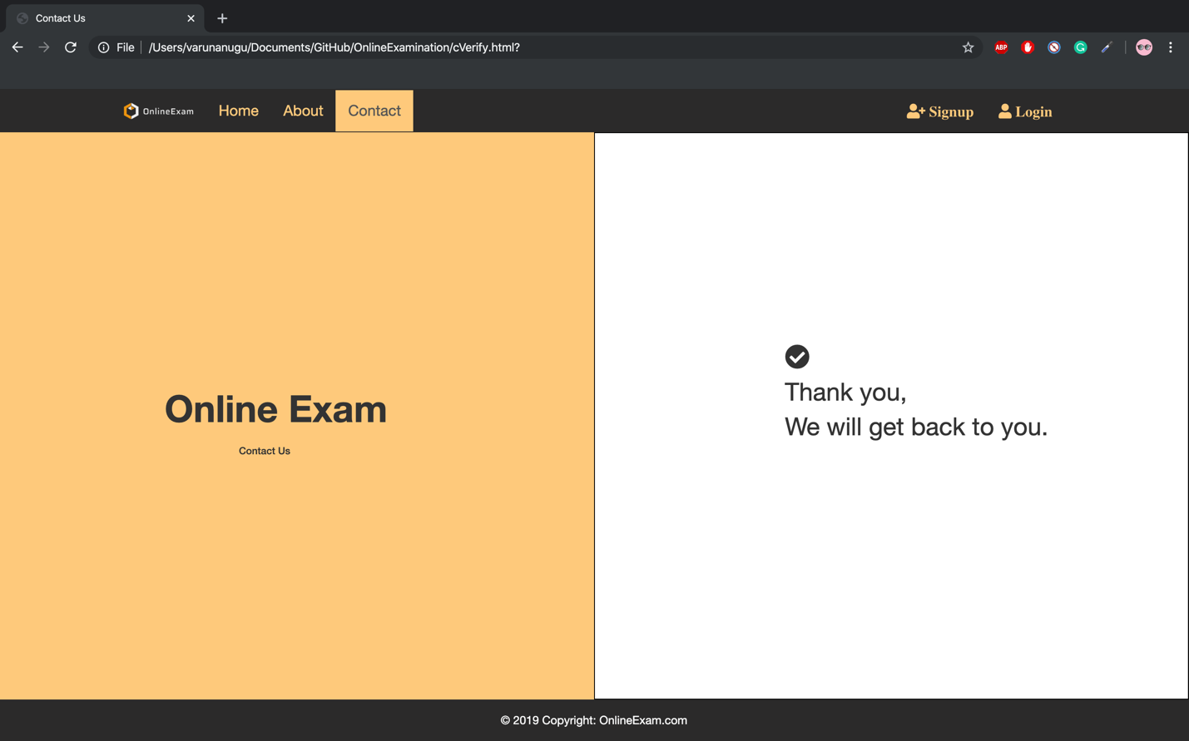

**Signup page:**

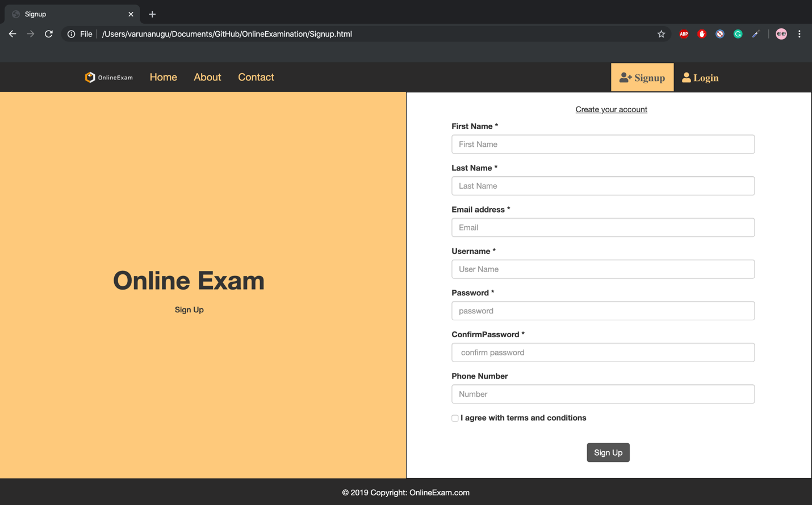

**Login page:**

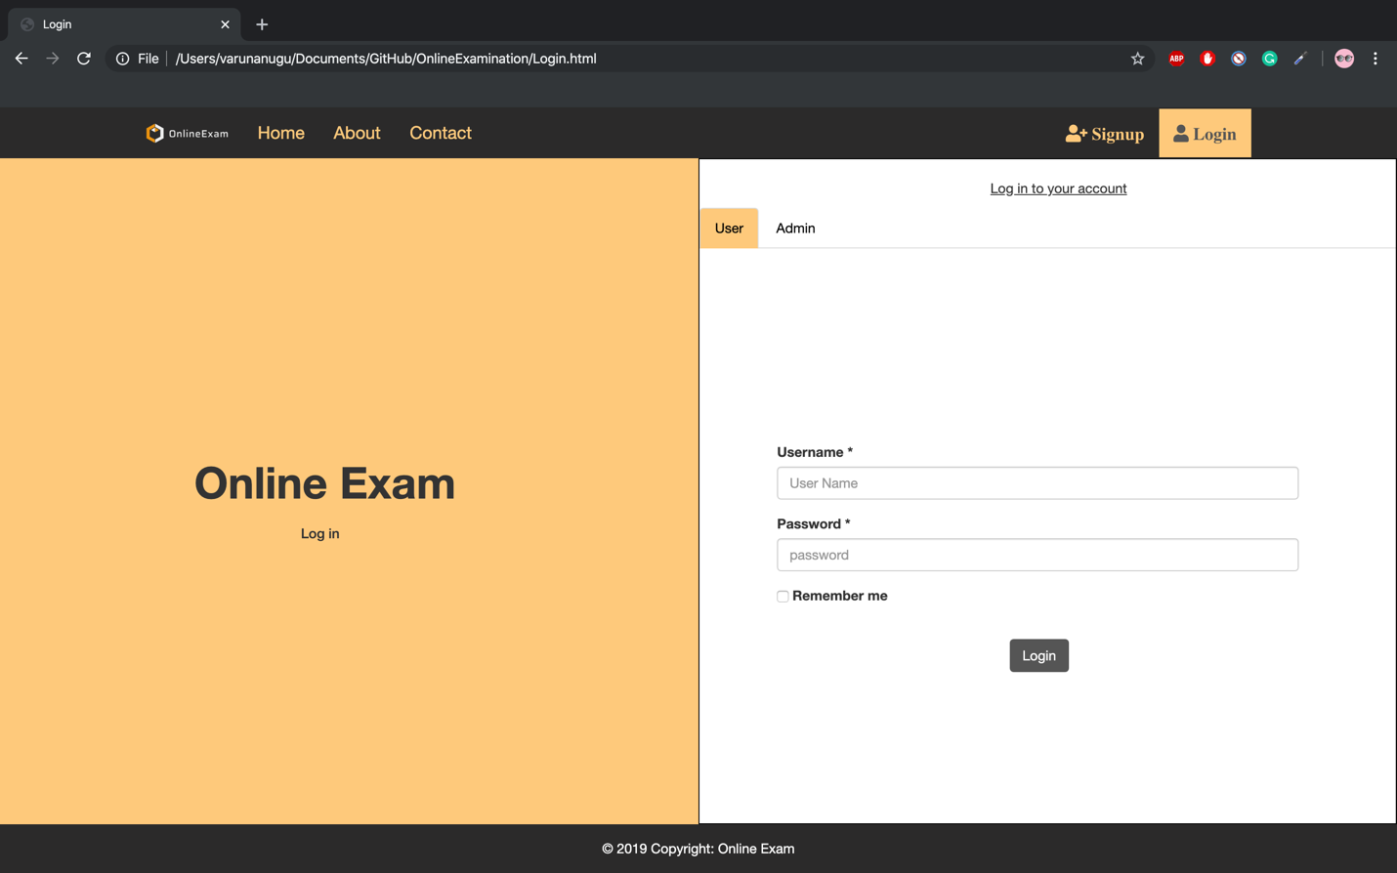

**User Home page:**

When we press login button After filling the required fields page redirects to the below page.

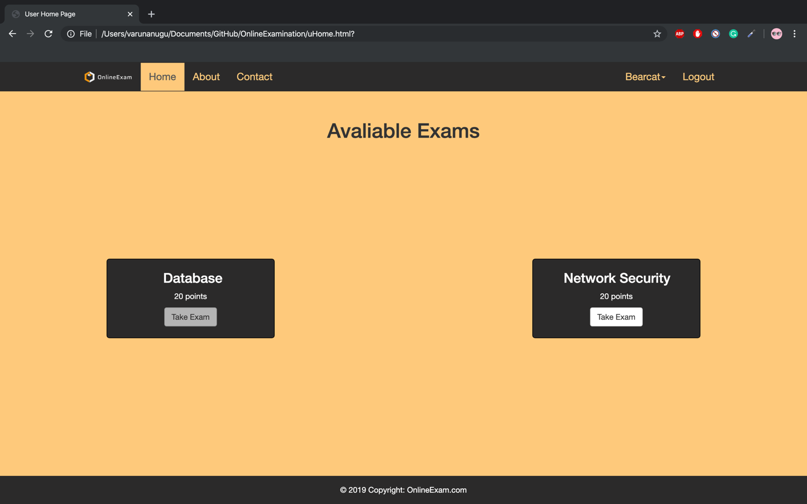

**NS Questions page:**

When we press Take Exam button we will navigate to this page.

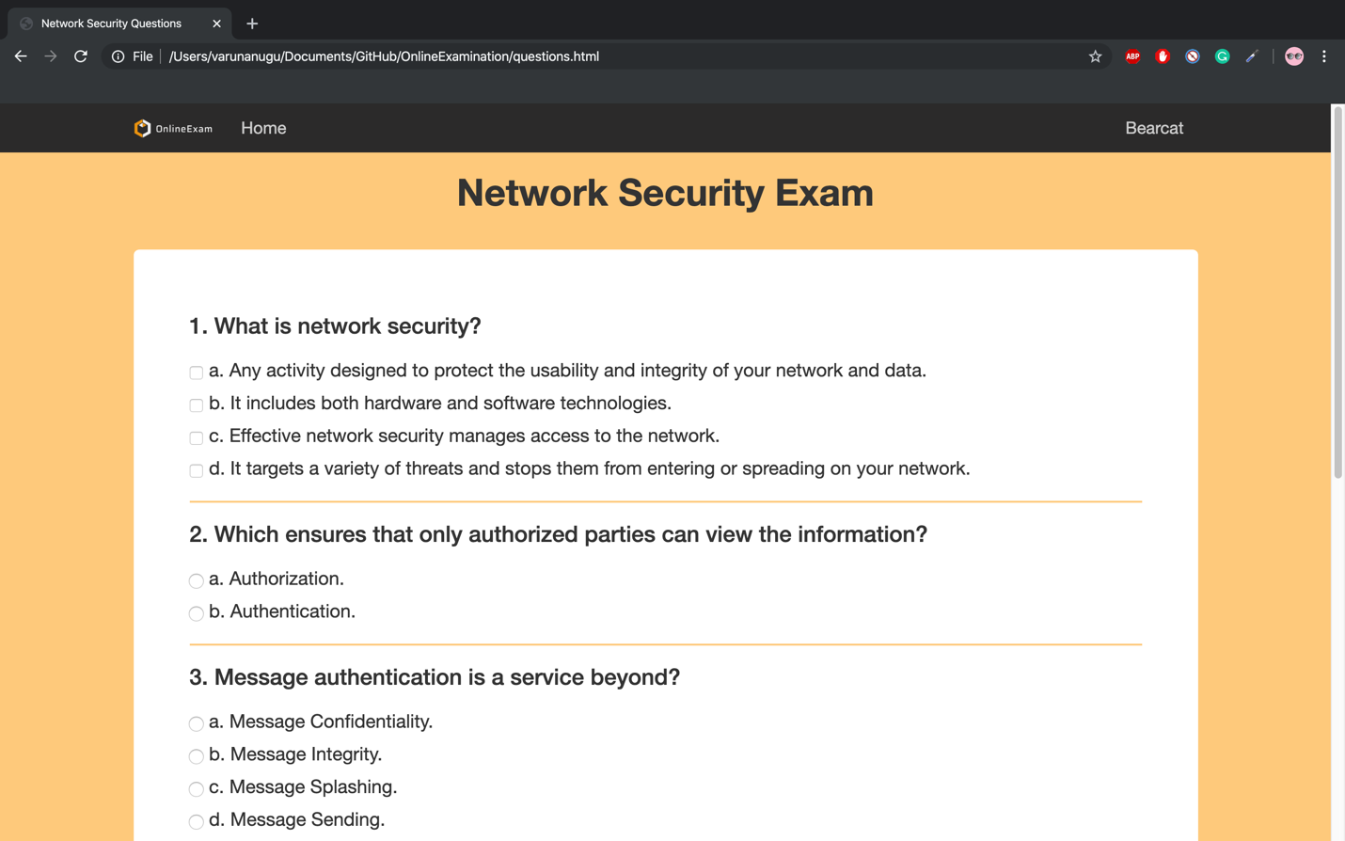

**NS Questions page:**

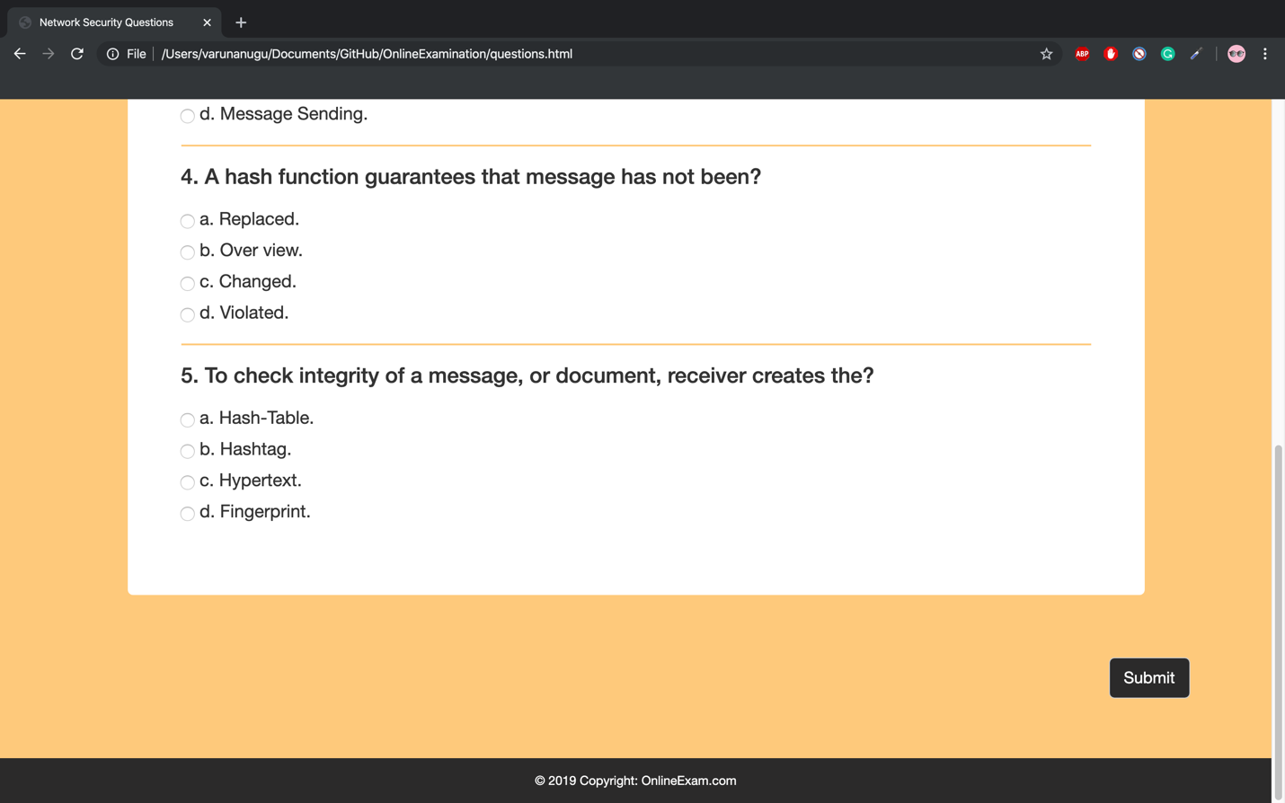

**Results Page:**

When we click submit button it redirects to the below page.

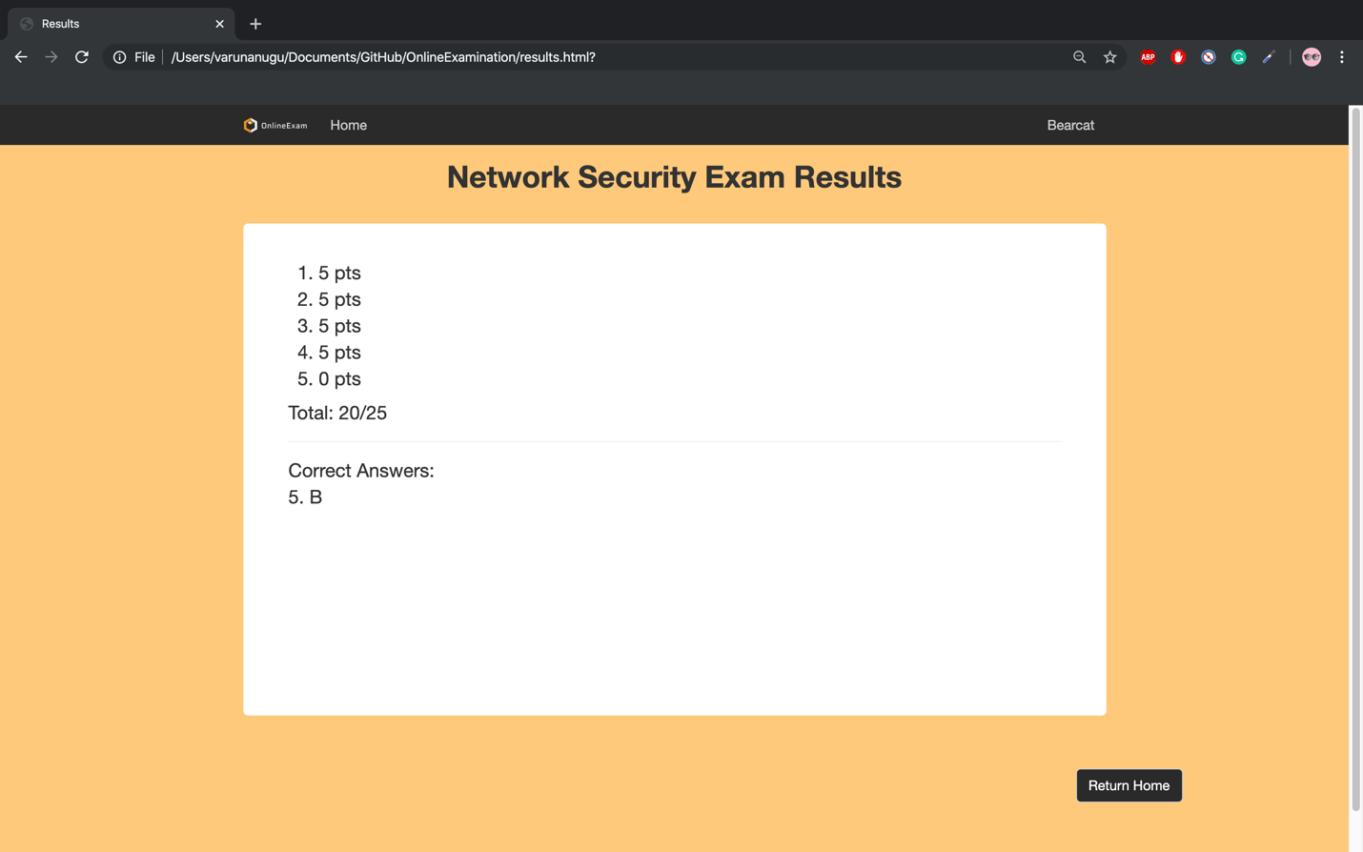

**Edit Profile page:**

Click the bearcat dropdown menu in the navigation bar and go to edit profile you can find it.

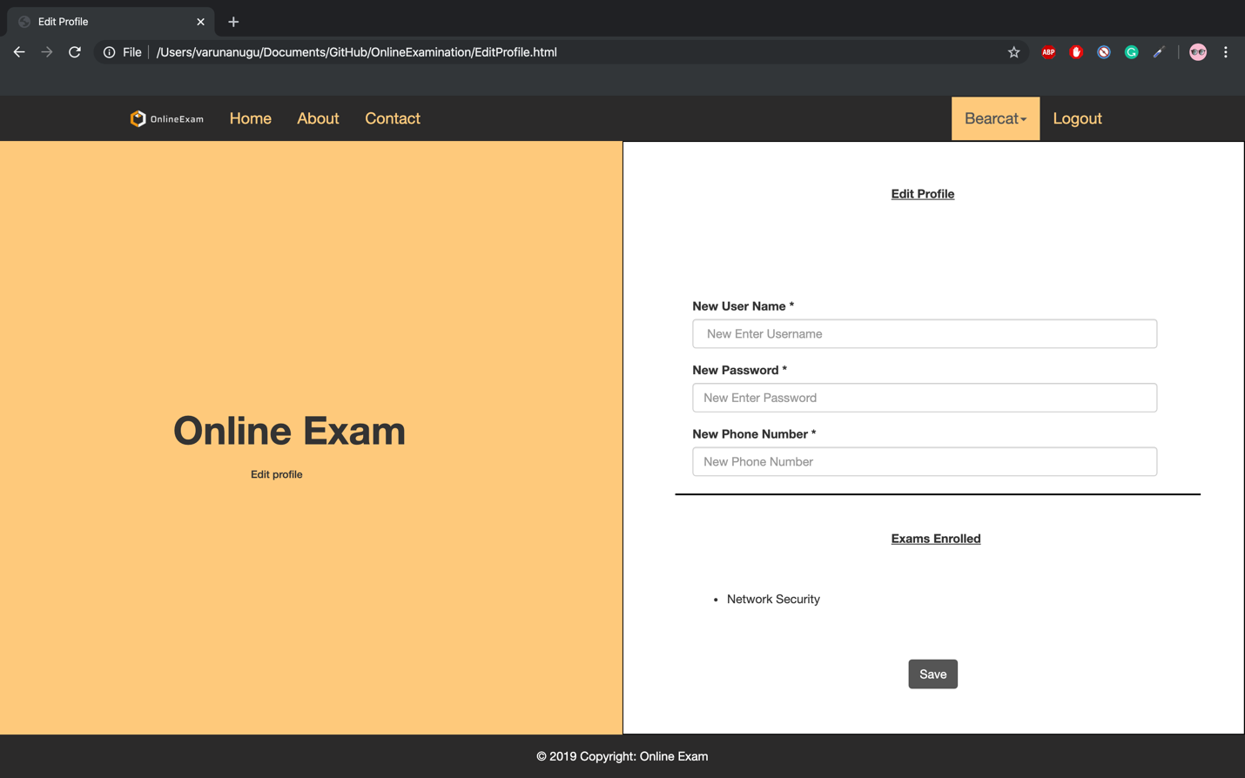

**Profile Update page:**

When we press save button After filling all the required fields it will navigate to this page.

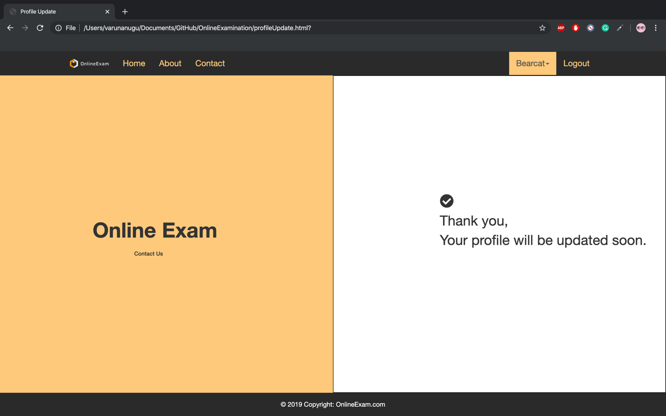

Then press logout to come back to login page and select Admin page redirects to the below page.

**Admin Login page:**

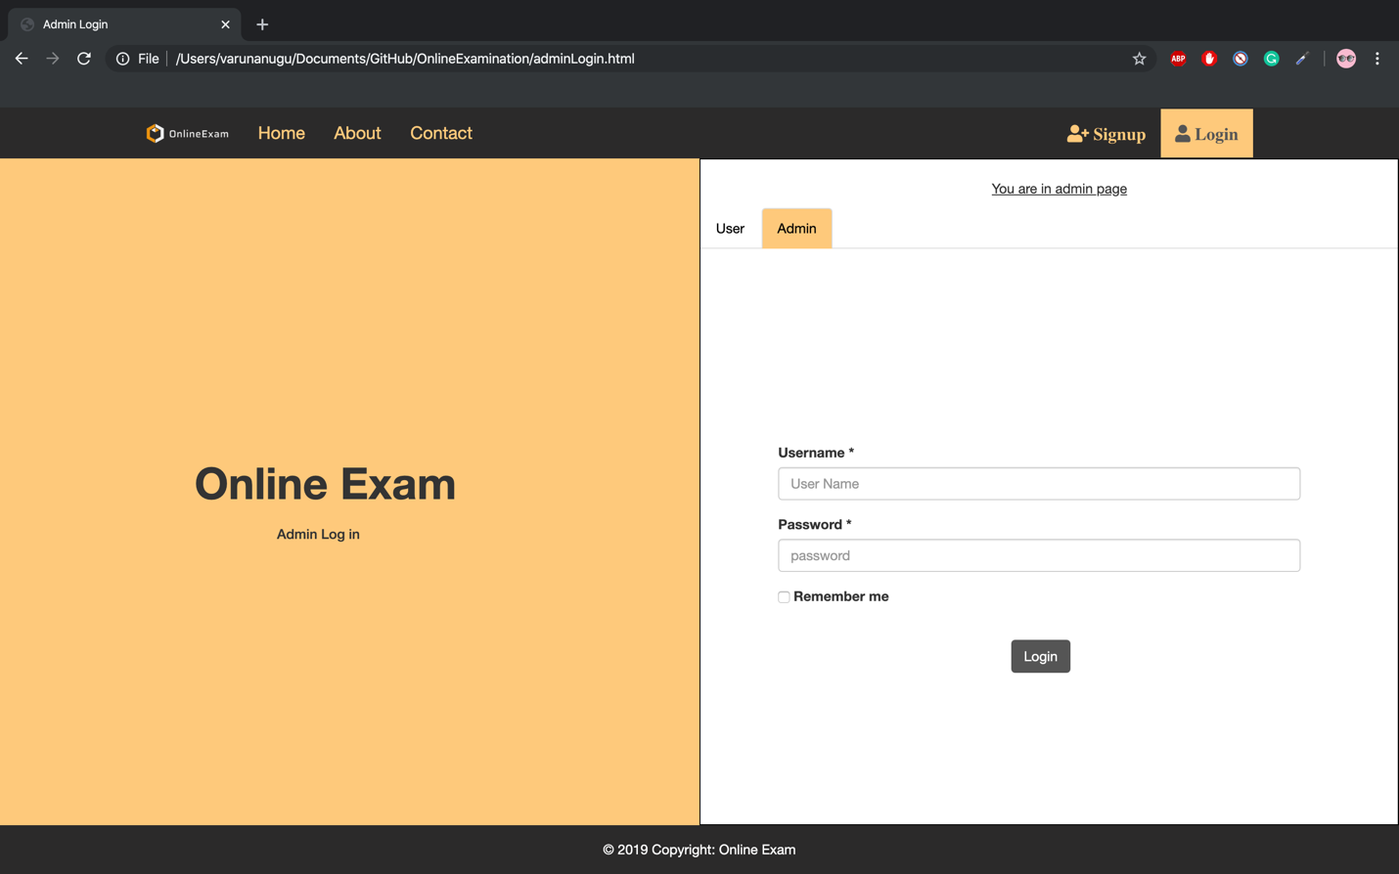

**Admin Home page:**

When we click login button after filling the required fields to navigates to admin home page.

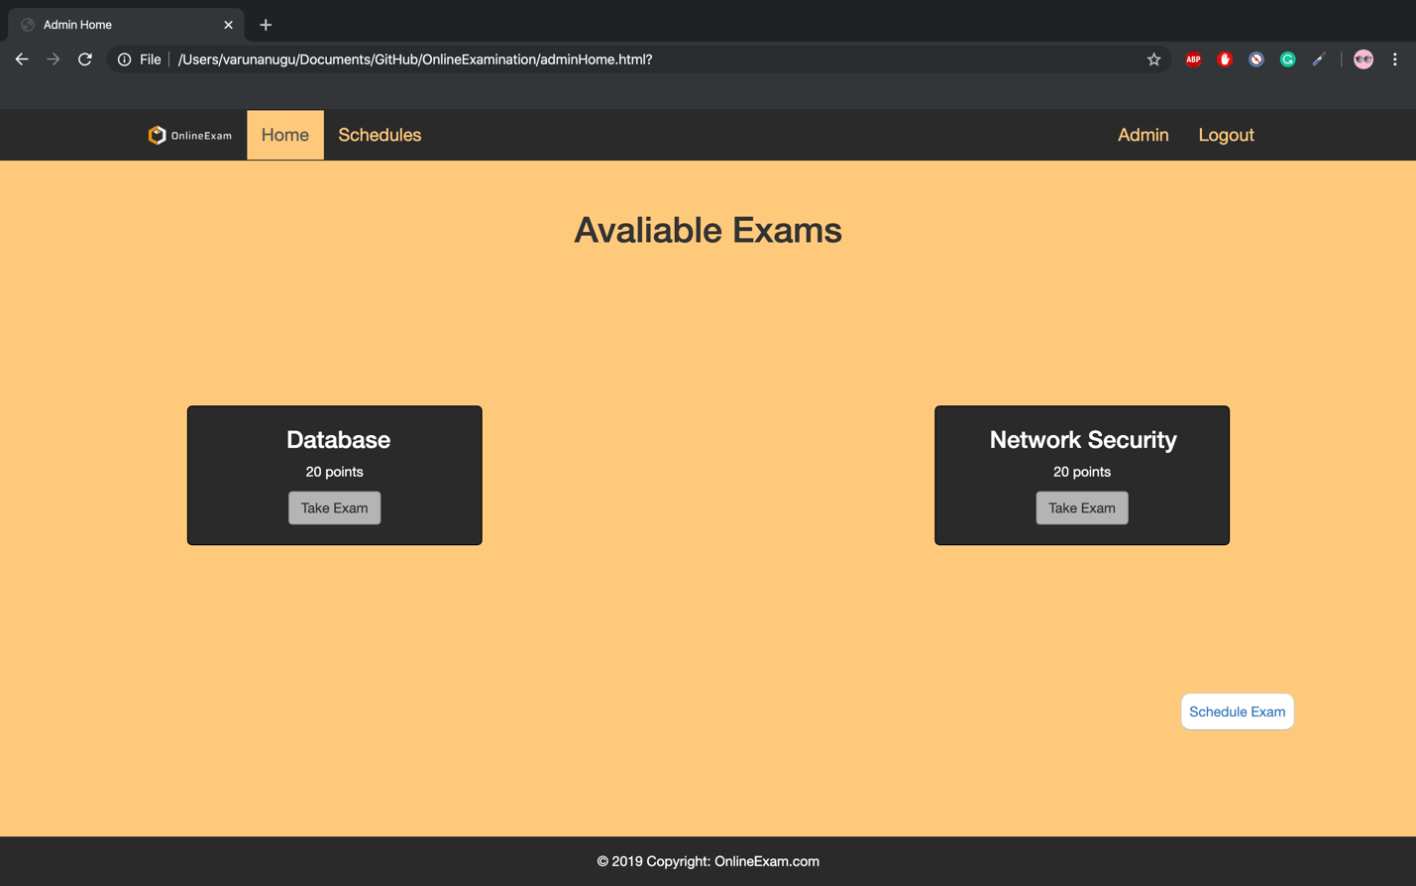

**New Exam page:**

When we click schedule exam button in admin home page it directs to the below page.

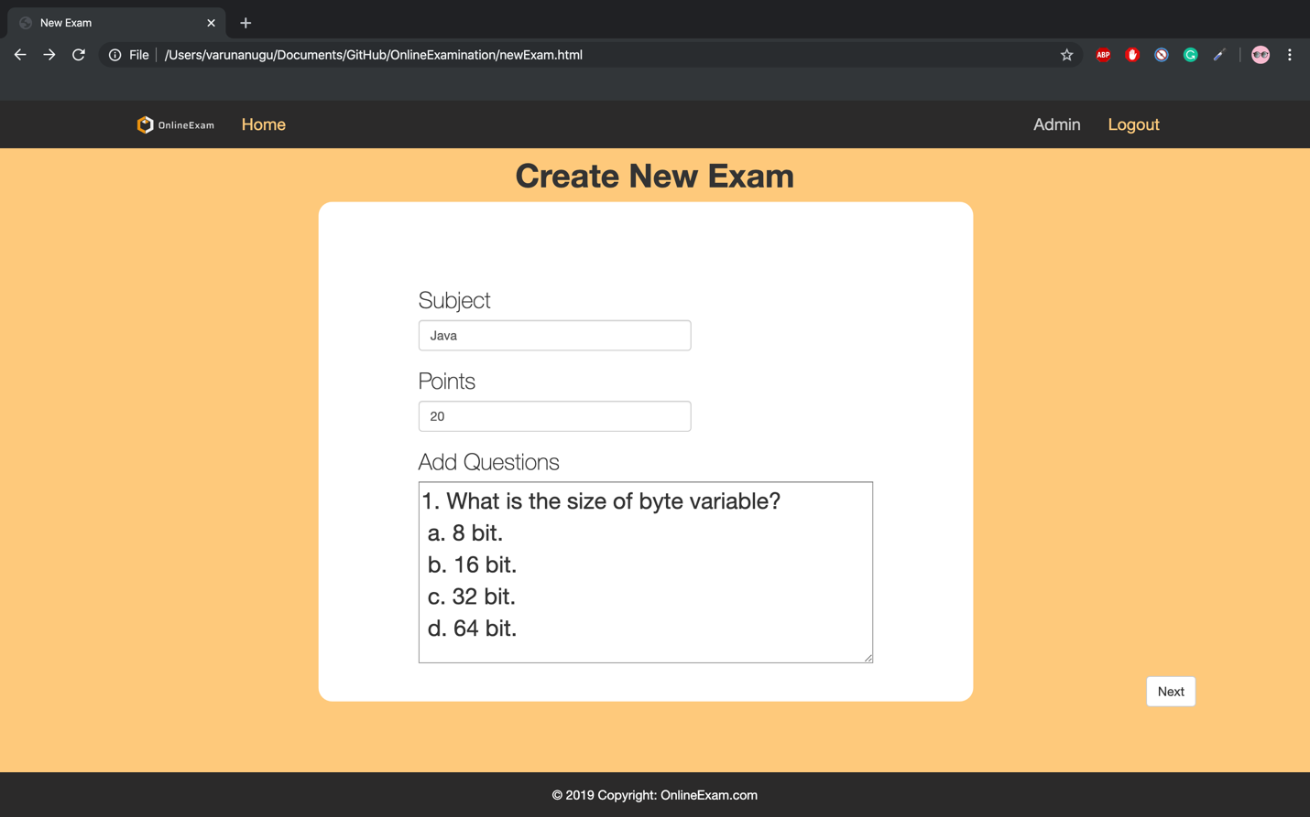

**New Questions page:**

Now you can see the question has been added.

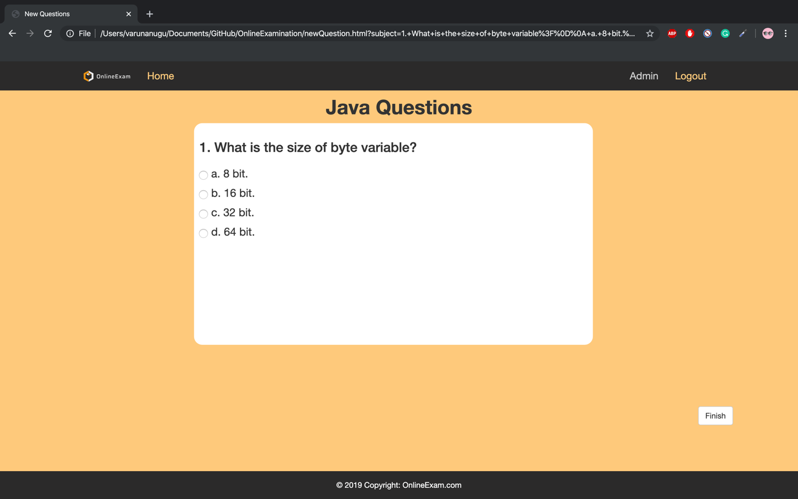

**Exam added page:**

When we click finish button exam will be added.

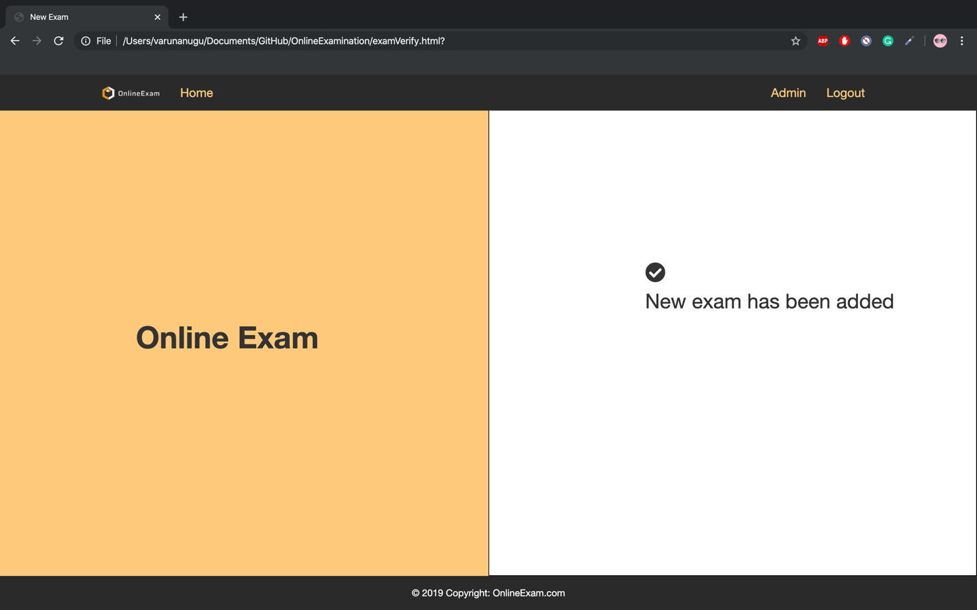

**Admin home page:**

When you go back to home, we can see java exam has been added to the list.

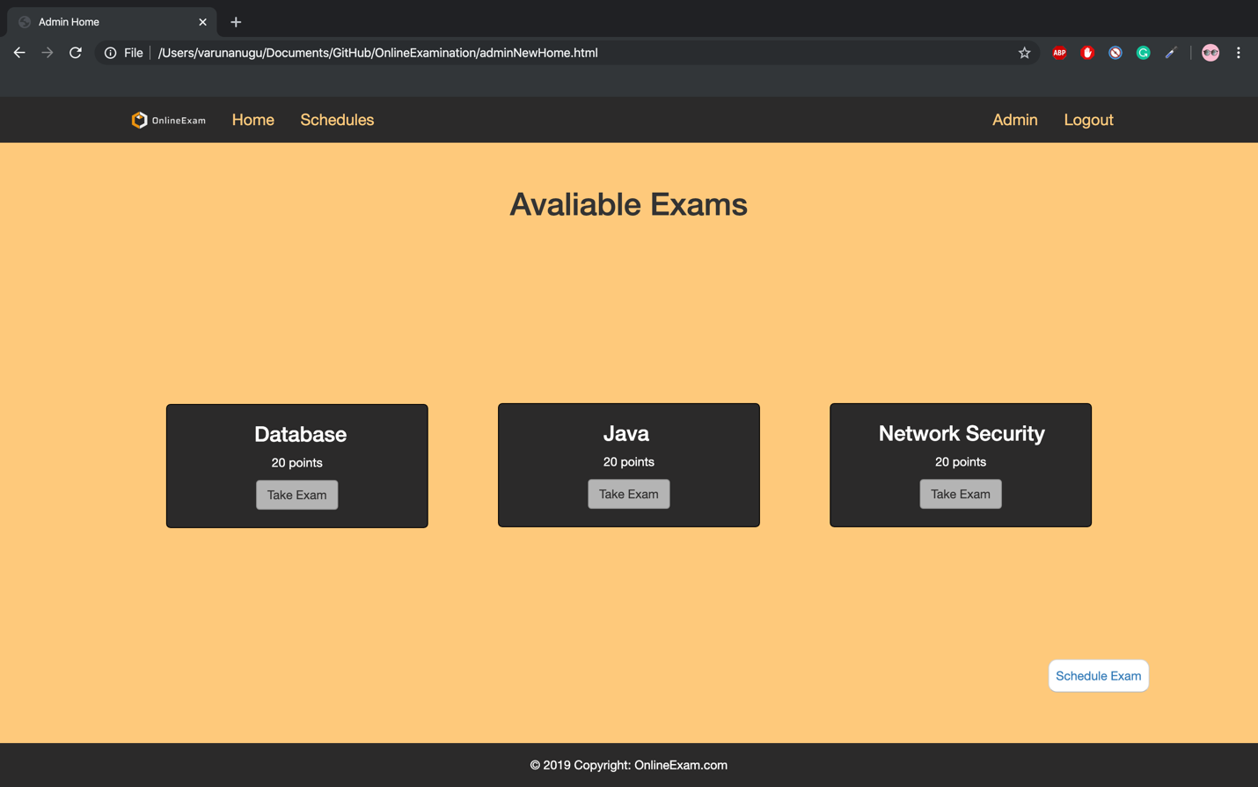

**Schedules page:**

Here we can manage the user registration.

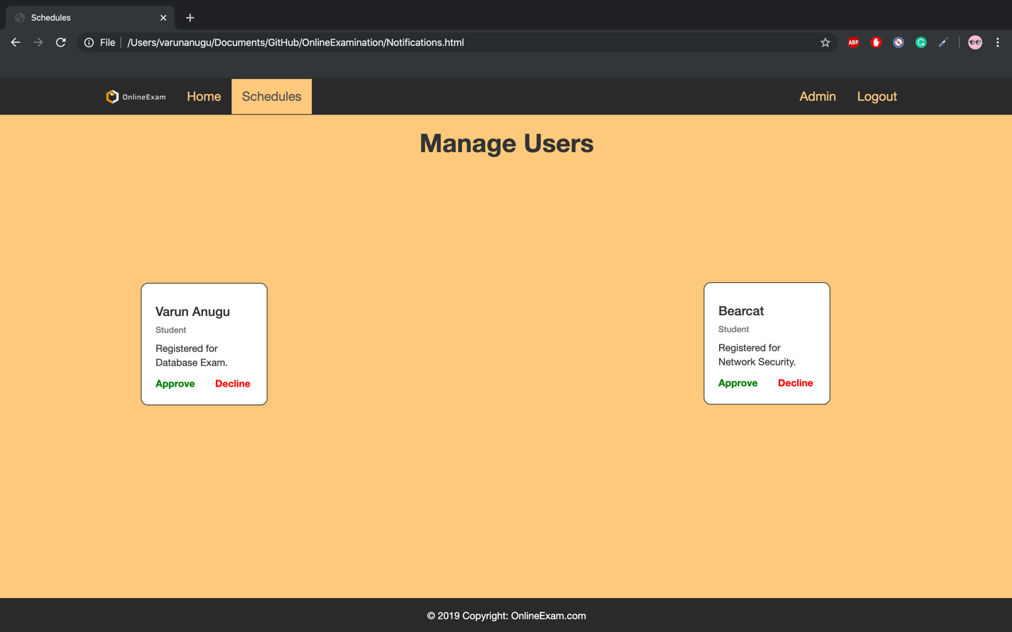

When we press the decline button for Varun request, user will be deleted.

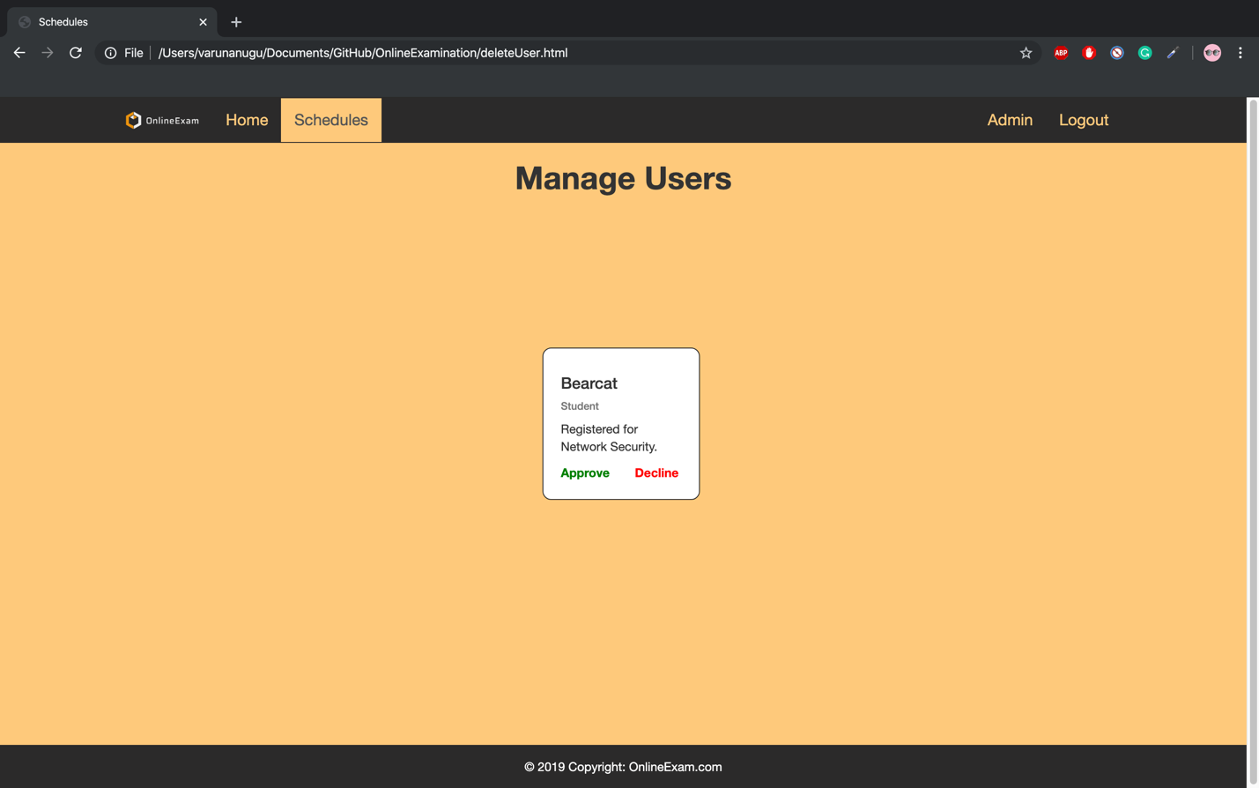

When we press approve button for bearcat request, we can it is approved.

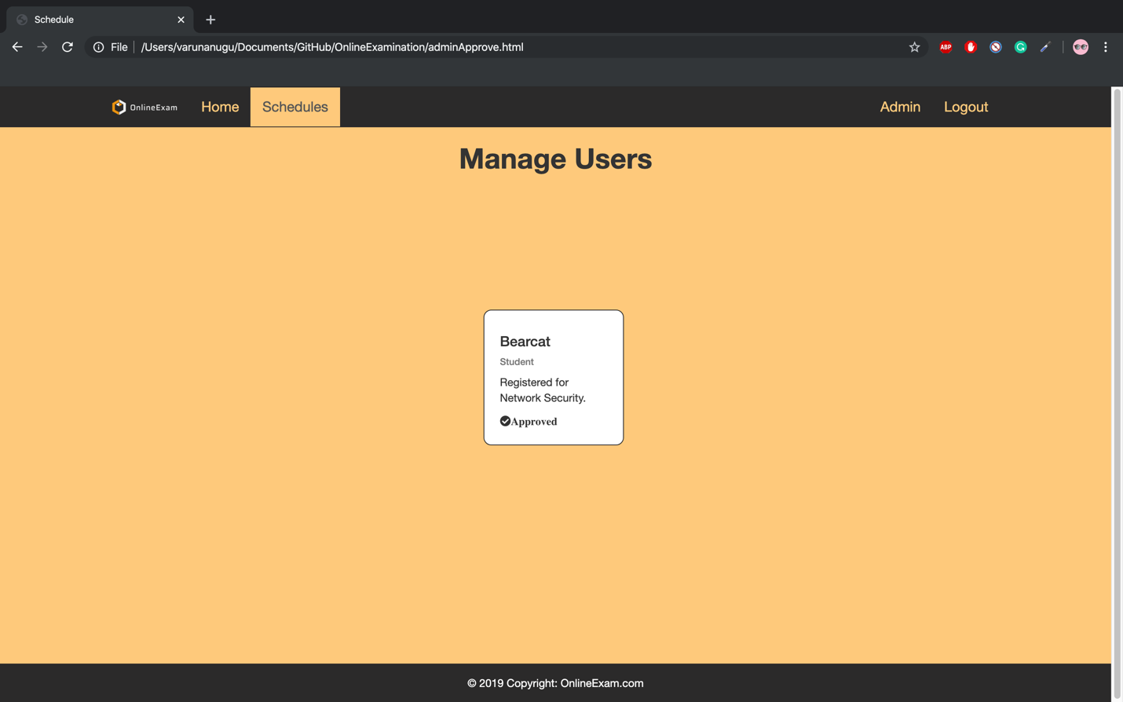

Finally, if we press logout button page navigates to the original home page.



**Heuristique Evaluation:**

**Golden Rule 1: Strive for Consistency**

We have followed same user interface to all the webpages in the project. The color combinations and the style of the pages is consistent across the website. The followed standard set of sequence for the entire project. The footer and header is consistent throughout the web application.

**Golden Rule 2: Cater to Universal Usability**

We have considered universal usability while developing the website. Any user from the world any age group user can easily use the website without any problems.

**Golden Rule 3: Offer Informative Feedback**

Our website provides good informative feedback to all the users. Let’s consider an example if the user enters wrong credentials while logging in or while signing up it provides a message to enter the correct credentials or use the standard format of exam.

**Golden Rule 4: Design dialog to yield closure**

If user perform any task it’s important to know that the task is successful or not. We will provide a popup for every task if the task is successful or even when it failed. If user takes an exam he/she will get the immediately after submission. So, user knowns that he have been submitted successfully.

**Golden Rule 5: Prevent Errors**

It is an important factor for a website to prevent the user from mistakes. This website provide an asterisk for all the fields that are mandatory. In sign up page the email address, name and password are mandatory so, we have used asterisk to indicate the user that this fields are mandatory which helps the user from making mistakes.

**Golden Rule 6: Permit easy reversal of actions**

In our website user can easily undo the actions. For instance, if admin rejected a user request accidently can reverse that particular action by clicking the undo on the top center of website. Similarly user can also do the action reversal by simply clicking on the undo.

**Golden Rule #7: Support internal locus of control**

If a user register for a course it will not happen immediately because the admin have to approve the user request. The admin can approve or reject the user request for registration. User need permission from the admin to take an exam.

**Golden Rule #8: Reduce Short-term memory load**

The user don’t have to remember anything from one page to other page. For instance the user don’t have to remember the courses he/she registered. The user can easily see the registered courses in the profile tab which reduces memory load on the user.